**LAB PROGRAM DAY 17**

**1. Closest Pair of Points by Brute Force**

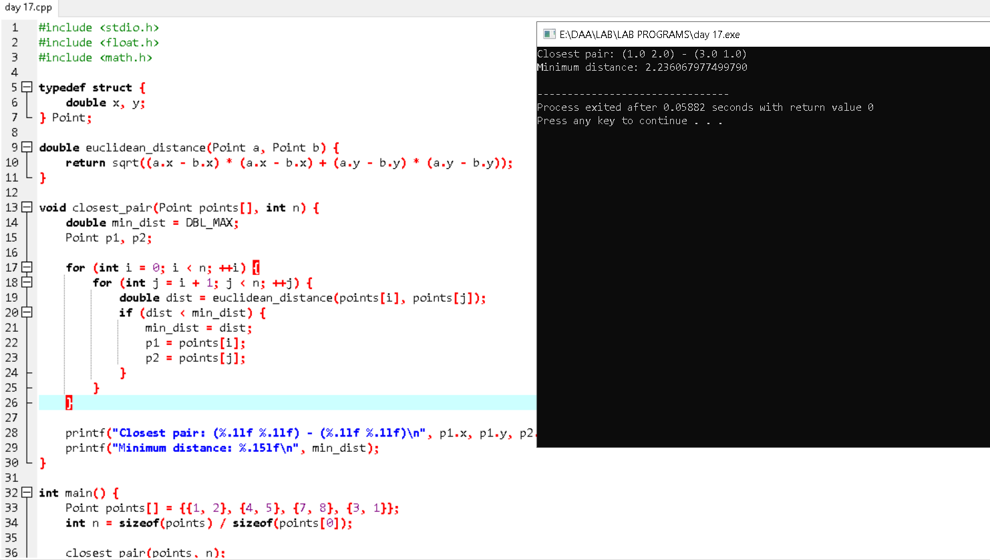

**2. Convex Hull by Brute Force**

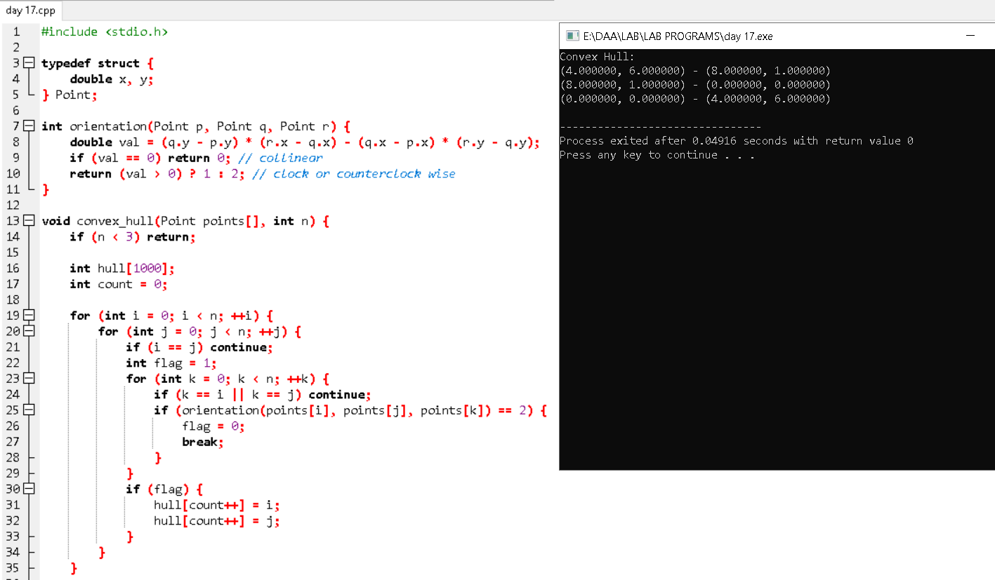

**3. Travelling Salesman Problem (TSP) with Exhaustive Search**

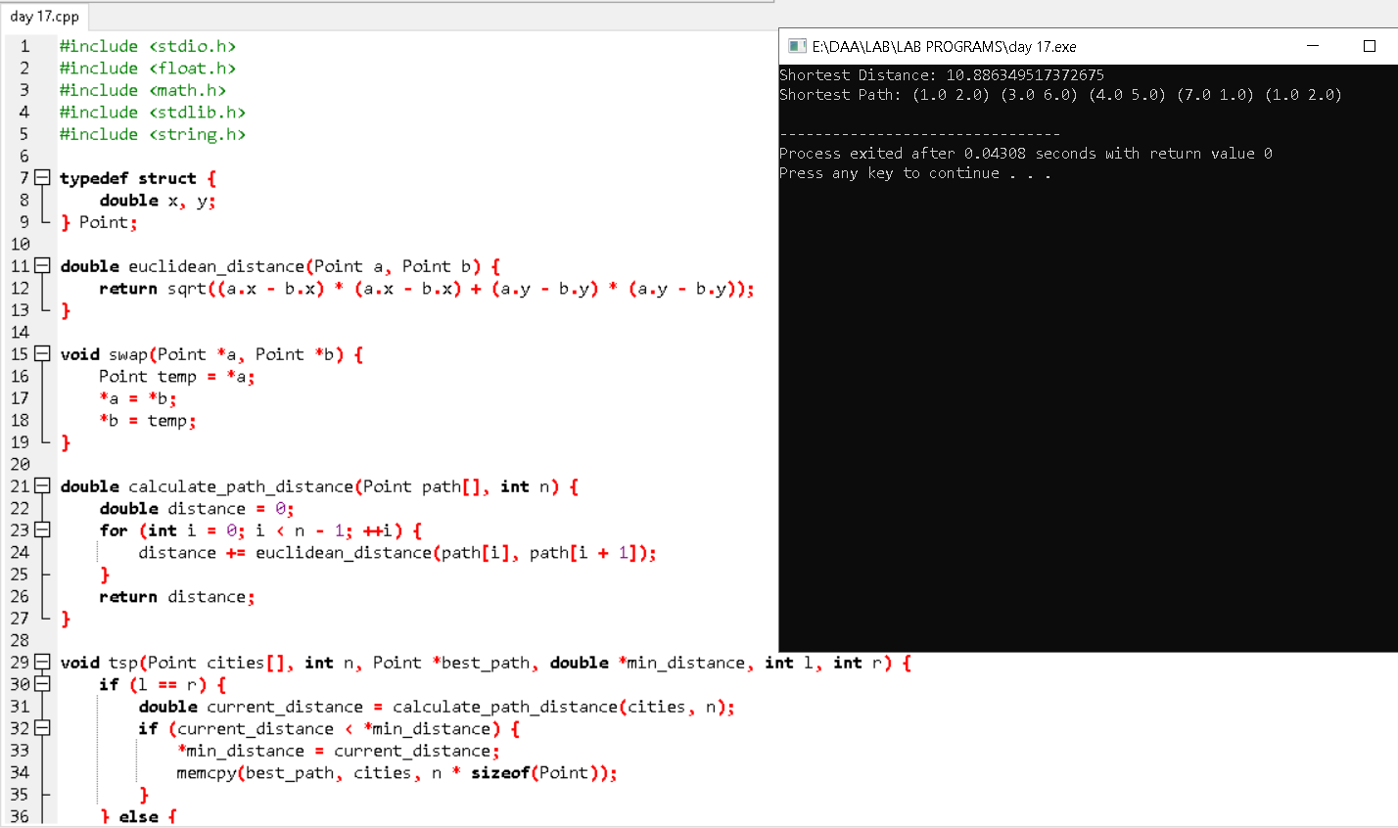

**4. Assignment Problem with Exhaustive Search**

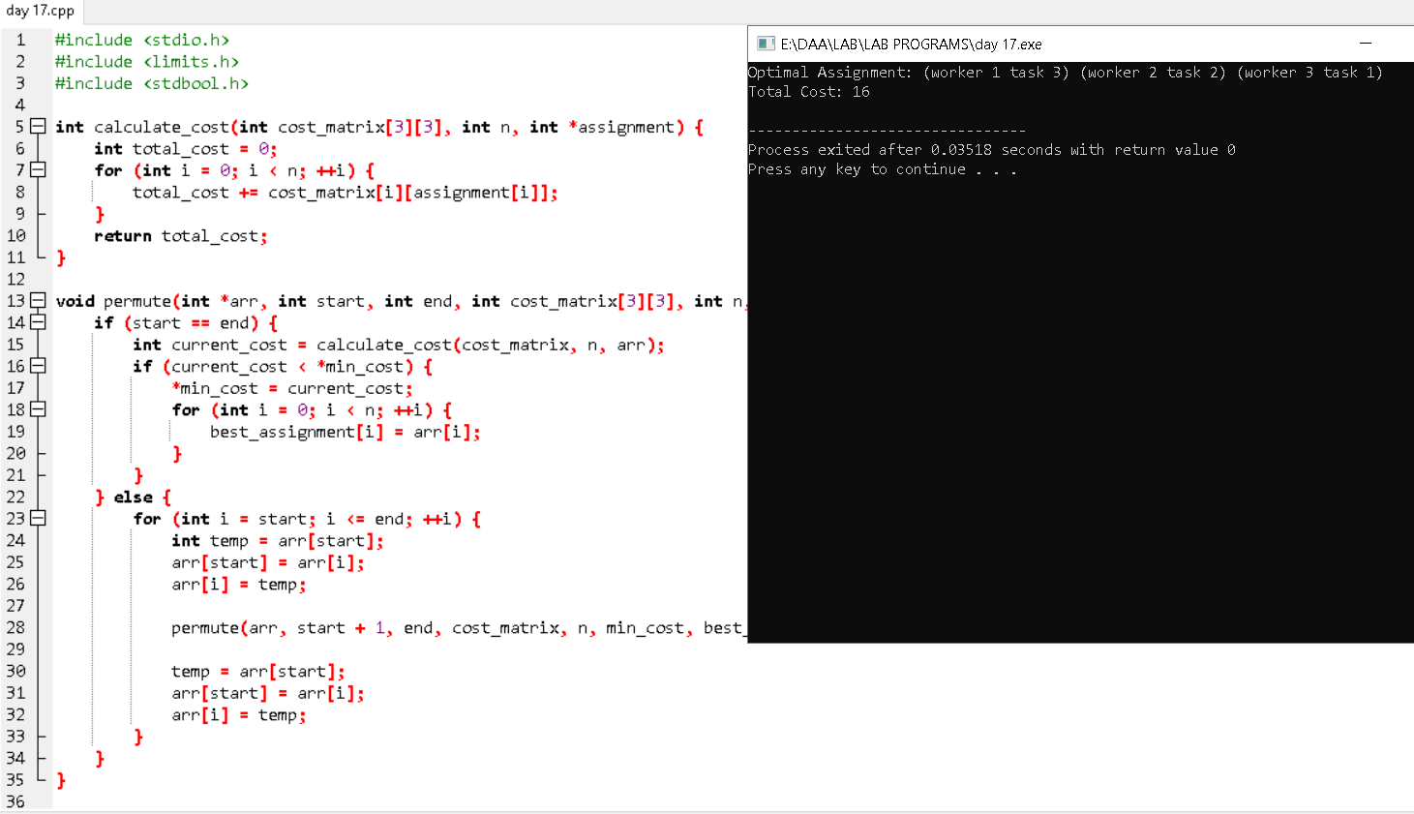

**5. Knapsack Problem with Exhaustive Search**

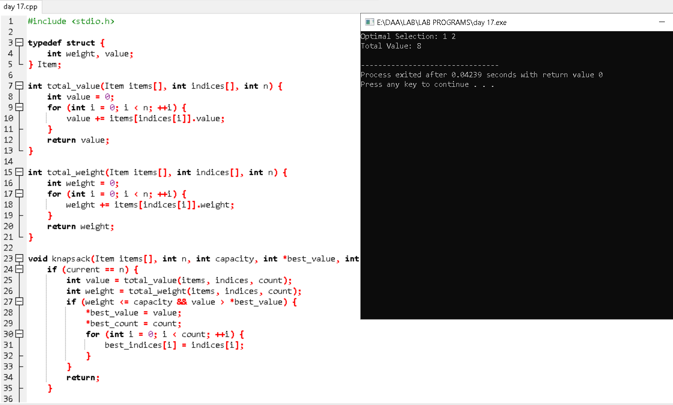

**6. Dice Throw Problem with Dynamic Programming**

